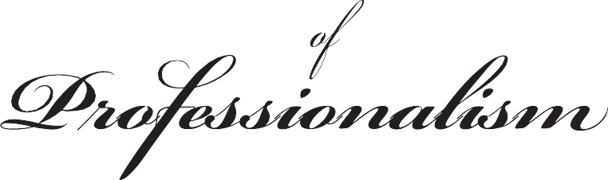

The legal profession is a learned calling. As such, lawyers should act with honesty and integrity and be mindful of our responsibility to the judicial system, the public, our colleagues, and the rule of law. We, as lawyers, should always aspire to the highest ideals of our profession.

- My word is my bond.
- I will conduct myself with honesty, dignity, civility, courtesy and fairness and will not engage in any demeaning or derogatory actions or commentary toward others.
- I will not knowingly make statements of fact or law that are untrue or misleading and I will clearly identify for other counsel changes I have made in documents submitted to me.
- I will be punctual in my communication with clients, other counsel and the court. I will honor scheduled appearances and will cooperate with other counsel in all respects.
- I will allow counsel fair opportunity to respond and will grant reasonable requests for extensions of time.
- I will not abuse or misuse the law, its procedures or the participants in the judicial process.
- I will cooperate with counsel and the court to reduce the cost of litigation and will not file or oppose pleadings, conduct discovery or utilize any course of conduct for the purpose of undue delay or harassment of any other counsel or party.
- I will not engage in personal attacks on other counsel or the court or use the threat of sanctions as a litigation tactic.
- I will support my profession’s efforts to enforce its disciplinary rules and will not make unfounded allegations of unethical conduct about other counsel.
- I will work to protect and improve the image of the legal profession in the eyes of the public.
- I will endeavor to improve our system of justice.
- I will use technology, including social media, responsibly. My words and actions, no matter how conveyed, should reflect the professionalism expected of me as a lawyer.
- I will seek opportunities to be of service to the bench and bar and assist those who cannot afford legal help.
- I will be supportive of new members in the profession.
- I will stay informed about changes in the law, communication, and technology which affect the practice of law.

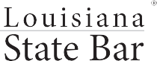Following approval by the Louisiana State Bar Association House of Delegates and the Board of Governors at the Midyear Meeting, and approval by the Supreme Court of Louisiana on Jan. 10, 1992, the Code of Professionalism was adopted for the membership. The Code originated from the Professionalism and Quality of Life Committee, and
was revised in June 2018.

