Louisiana State Bar Association

Black History CLE Seminar

February 15, 2018
3:00 pm – 5:00 pm

Adams and Reese LLP
450 Laurel Street, Suite 1900
Baton Rouge, LA 70801
Networking Reception to Follow

Attorney Registration Form

□ Judge Bar Roll Number
□Ms.□Mr. Name First Name for Badge Firm / Company Address
City/State/Zip

Office Phone
Fax

E-mail

□ Check here or contact the LSBA if you have a disability, dietary restrictions or a food allergy which may require special accommodations at this conference. The LSBA is committed to ensuring full accessibility for all registrants.

This program is FREE!
2.00 CLE Credit Hours

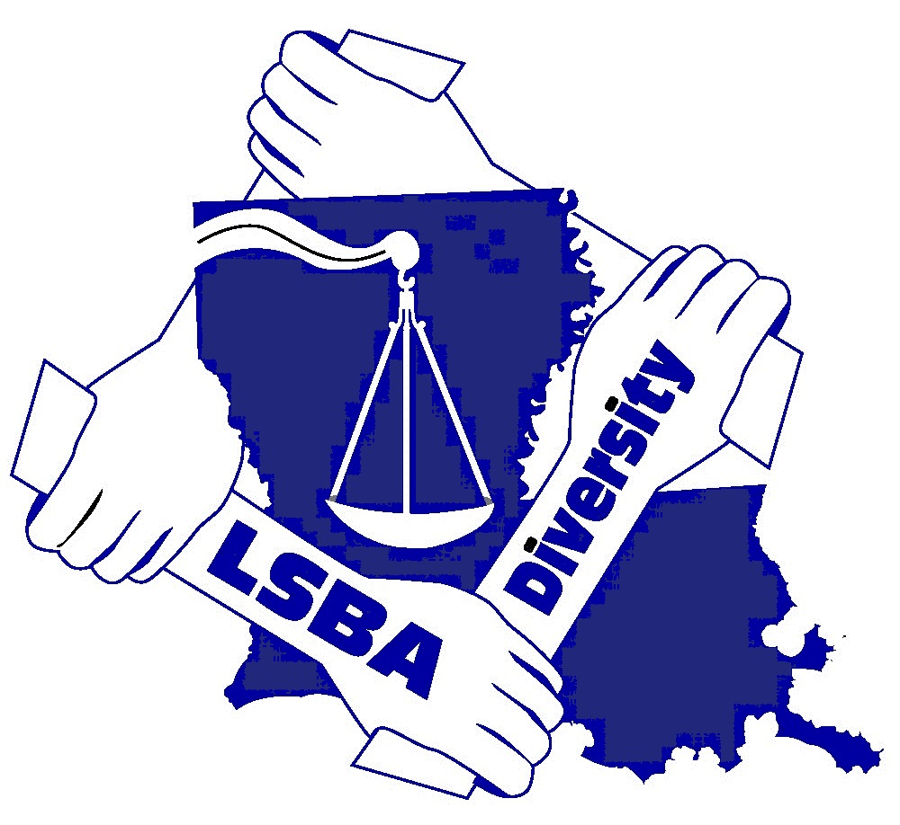
Please return this form to:
Louisiana State Bar Association
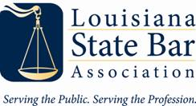
Attn: Member Outreach and Diversity
601 St. Charles Ave., New Orleans, LA 70130

