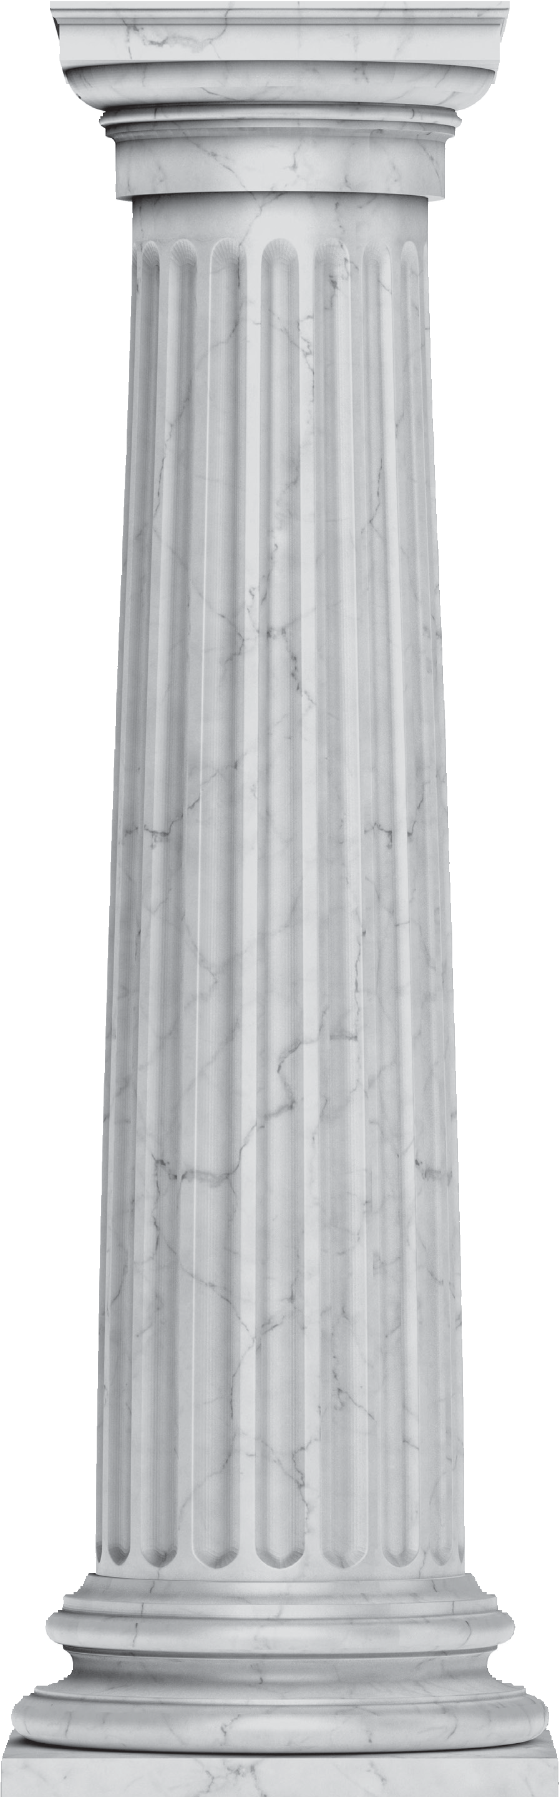

The
Lawyer’s Oath
I solemnly swear (or affirm) I will support the Constitution of the United States and the Constitution of the State of Louisiana;
I will maintain the respect due to courts of justice and judicial officers;
I will not counsel or maintain any suit or proceeding which shall appear to me to be unjust, nor any defense except such as I believe to be honestly debatable under the law of the land;
I will employ for the purpose of maintaining the causes confided to me such means only as are consistent with truth and honor, and will never seek to mislead the judge or jury by an artifice or false statement of fact or law;
I will maintain the confidence and preserve inviolate the secrets of my client, and will accept no compensation in connection with a client’s business except from the client or with the client’s knowledge and approval;
To opposing parties and their counsel, I pledge fairness, integrity, and civility, not only in court, but also in all written and oral communications;
I will abstain from all offensive personality, and advance no fact prejudicial to the honor or reputation of a party or witness, unless required by the justice of the cause with which I am charged;
I will never reject, from any consideration personal to myself, the cause of the defenseless or oppressed, or delay any person’s cause for lucre or malice.
So help me God.

